RECYCLE your oral care product packaging
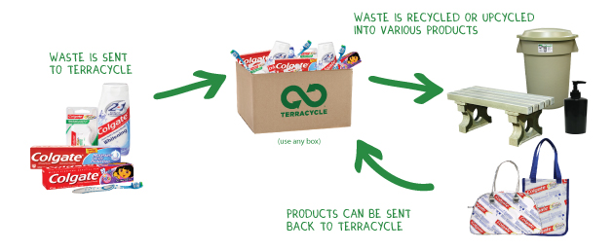
Colgate®, a global leader in oral care, has partnered with TerraCycle® to help provide a second life for toothbrushes, toothpaste tubes, toothpaste caps, floss containers, and their outer packaging materials.
Help divert landfill waste by sending your oral care products to TerraCycle. For each approved item received, your collection location will be awarded two TerraCycle points. These points can be redeemed for a payment of $0.01 per point to the non-profit organisation or school of your choice.
Participating in a TerraCycle Brigade is totally free! There are no signup or participation fees, and the shipping is covered by the program. Once you have joined the Colgate Oral Care Brigade, simply follow the steps below to receive your TerraCycle points:
1. Collect oral care waste products (examples of approved waste listed below) to fill up a box or bag. Remember to reuse a shipping box or bag and use eco-friendly padding. Please note that you will need to send shipments that weigh at least 2 kilograms in order to receive the TerraCycle points donation.
2. Request a pre-paid shipping label from terracycle.com.au. To acquire a pre-paid label, simply access your TerraCycle account online, and click “REQUEST A POSTAGE LABEL”. Select the "Send Me a Postage Label" option and TerraCycle will email a pre-paid shipping label to you.
3. Ship the box to TerraCycle by affixing the pre-paid postage label and dropping it off at an Australia Post Office.
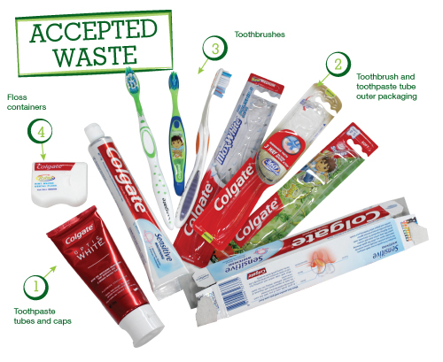
Oral Care accepted waste:
1. Toothpaste tubes and caps
2. Toothbrushes
3. Toothbrush and toothpaste tube outer packaging
4. Floss containers
Go to http://www.terracycle.com.au/en-AU/brigades/oral-care-brigade.html for all the details and register as a brigade member.

For more detailed information please check out the Oral Care Brigade FAQ.
And to make collecting all your waste that much easier, download our helpful TerraCycle "Collect, Store and Ship Guide" for some tips and tricks that will make the collection process simple and mess-free. Also check out our Oral Care Brigade poster to help promote your collection efforts.

